Report from visit at Kottamia observatory

(technical report of comissioning and performance testing of Okayama spectrograph)

Petr Škoda

Astronomical Institute of the Academy of Sciences,
Ondřejov, Czech Republic

skoda@sunstel.asu.cas.cz

Introduction

This report describes the activities performed during scientific visit of Dr. Škoda in Egypt in May 2008 .

From the whole stay in Egypt (6.5-18.5.2008) six nights were spent at the Kottamia observatory under the supervision of Dr. Gamal Ali with setting up the spectrograph and performing observations. We obtained spectra of several stars both in low dispersion (with grating 300 gr/mm) and high dispersion (1800 gr/mm) modes. In addition to Zeta Oph and Arcturus we have concentrated mostly on Vega as a prototype of star with smooth almost featureless continuum with clearly visible Balmer lines. The other reason was the possibility of direct comparison with exposures secured with the coude spectrograph and OES at the 2m telescope in Ondřejov.

Preliminary checks and adjustments
As the spectrograph had not been in use for more than a year a number of adjustments had to be made. The loose flat lamp was tightly adjusted to give smooth and regular illumination as well as the proper voltage was found giving the reasonably blue continuum.. The performance of CCD controller and camera was checked before the cooling by LN2 started.. Several offsets, dark frames, flat fields and comparison arcs were taken before attaching the spectrograph to the telescope. The analysis of frames were done in native application delivered with the CCD – the Pixcel working with its own data format (APF) but for advance analysis a standard astronomical format FITS was needed.

FITS headers
The Pixcel application is able to convert the native APF format to FITS but only one file can be converted each time (no batch conversion), which is very tedious and impractical. Moreover the FITS files produced are not conformant to official FITS standard (unsigned 16 bit integers should be stored as signed 2's complement 16bit integers and the keywords BZERO=32768 and BSCALE=1.0 should be present together with BITPIX=16). Instead the Pixcel program writes only unsigned numbers (0 to 65536) but the header is as expected. This inconsistency causes the wrap-around behaviour of values higher than 32768.
We have successfully tested to ways of correction. Either the BZERO keyword should state BZERO=0.0 or the IRAF task „rfits“ with parameter „datatyp=ushort“ can be used to massively convert all wrong FITS files. To distinguish them we used suffix „.fit“ for wrong ones and „.fits“ for corrected - under Linux.
After correction the analysis in task „ds9“ (either in Windows or Linux) was performed. smoothly.

Spurious CCD noise
After first exposures of flat field calibrations the strange type of noise in frames was revealed. Everything was OK when the exposure levels were below about 1000 ADU and than parts of image became contaminated by strange patterns of several bright and dark points (Fig.1).
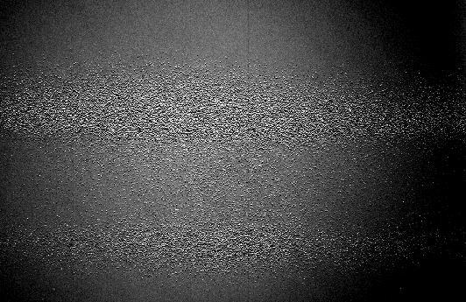
Fig 1 : Presence of the spurious noise in 2D frame
The contaminated parts of chip were showing very high noise amplitude not corresponding to the Poisson noise at given exposure levels. (Fig.2). Many potential sources in optics (scratches, shadowing …) were quickly eliminated as well as a suspected electronic disturbances (all controller cables were reconnected allowing enough space between each other, the grounding points were checked as well as phases of power sockets).
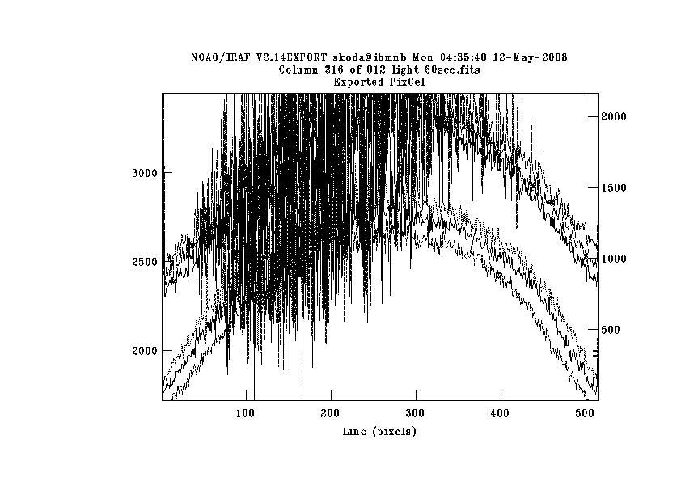
Fig 2: Spurious noise in flat field cuts

The only solution we have found was to expose to very high light levels (still below the saturation) , as the relative contribution of spurious noise was smaller (the amplitude of it seamed to be almost constant). We reported everything to the manufacturer C. Mackay (Pixcellent UK) and the investigation lead to the suspicion that one phase of CCD has different voltage amplitude than expected. The further experiments have been performed by Dr. Gamal Ali.
According to the manufacturing tests and delivery report the Pixcellent CCD camera is of excellent quality and after solving the (probably minor, but tricky to find) problem with electronics the spectrograph will be able to observe very faint objects registering easily every single photon (see next point).

Gain setup
The default setup of Pixcel application recommends the CCD readout speed of 83.3 kHz which gives the gain about 5 e/ADU. The theoretical ADC (A/D converter) saturation occurs than at 326000 electrons. However, the full well of this particular chip is about 90 000 electrons, so that the default gain would not use the full numeric range of the ADC. The estimated readout noise at this setup is 3.4 electrons. Therefore this mode is recommended only for extremely high SNR work (e.g. detailed line profile analysis at high dispersion), but the physical non-linearity effects have to be checked.
For typical work on fainter objects we recommend readout speed 25.3 kHz representing gain 1.16 e/ADU. In this mode the maximal acceptable signal before non-linearity occurs is about 90000/1.16 = 77000 ADU. This is still above the numerical saturation 65536 ADU so that the full range of ADC can be used freely with guaranteed linearity range. The readout noise measured by manufacturer is than less than 2 electrons.

Flat field calibration lamp
The lamp is mounted inside the spectrograph and can be manually inserted in front of the slit by the handle. It requires the precise adjustment to give homogeneous illumination of the slit. As it is very bright, the exposure time just below the saturation level is too short in comparison to the shutter opening speed. It may cause uneven illumination of the chip in different zones. That is why we decided to put an additional diffuser (sheet of white paper) between the lamp and slit.
In general, however, it would be better to use the dome flat (as its illumination is more similar to the stellar illumination than the lamp inside spectrograph). The recommended way is to point the telescope to the illuminated white circle or square attached to the dome. The lamps should be high intensity halogen bulbs without the UV protective coatings.

Optics – vignetting
The given construction of very bright high speed Schmidt camera (i.e. with very low focal ratio) introduces inevitably the strong vignetting of input beam. The edges of the objective lens are always very dark – this means that the full length of CCD chip cannot be used – the edges are without signal. Experiments shows that about 1300 pixels from 2048 have enough light only. The rest has to be cut off before data reduction, not to disturb by numerical oscillations on flat-fielded frames. The additional noise is introduced by the flat field in extreme UV region, where the flat lamp does not shine enough and where the CCD quantum efficiency is low as well.

Arc comparison lamp
The Okayama spectrograph was originally used for photographic plates. Hence the current setup with the comparison arcs projected at both sides of stellar spectrum strip. This brings about many complications with precision and reduction in general. The arcs are in the regions outside of the slit so that they cannot be flat-fielded. Moreover the identification of lines has to be done twice at distant places than the pixels gathering stellar light and interpolated to the middle. As the chip is never perfectly aligned with dispersion and for the low dispersion system the differential refraction comes in play (causing the curved projection of stellar strip), non-linear transformation has to be applied to project the dispersion solution from comparison arcs to the middle of stellar trace. The lost of wavelength precision is than inevitably.
We recommend to reconfigure the spectrograph allowing the comparison lamp to illuminate the same piece of slit as star and flat. One possible solution is the replacement of flat lamp in its retractable holder by the comparison arc , using the dome flat at the same time.
Another problem is caused by the type of the arc lamp. The hollow cathode FeNe lamp has only few lines identified – all of them in red region only (Fig.3).
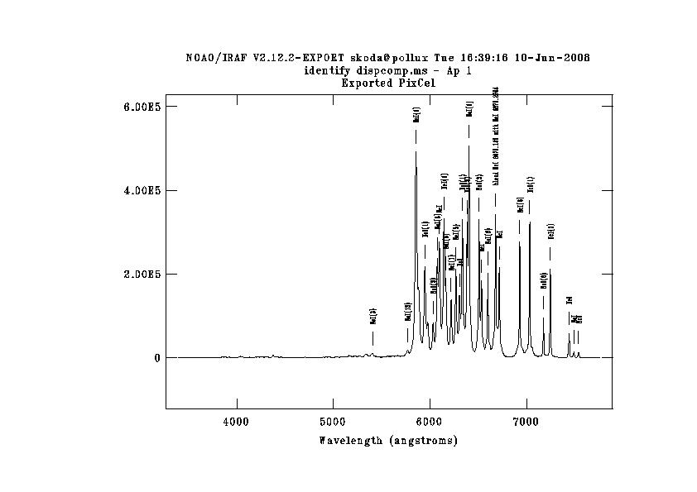
Fig 3: FeNe comparison arc lines
Thus it is impossible to calibrate well the low dispersion spectrum in the blue region. We recommend to replace the FeNe lamp by modern commonly used ThAr lamp (e.g by Heraeus).

Observation of Vega
We have acquired about 10 exposures of Vega both in low resolution (300 gr/mm) and high resolution (1800 gr/mm) mode. The 1800gr/mm observation was tuned to cover the red spectral region containing H alpha. The frames were exported to FITS files and converted to signed integers by in IRAF under Linux Debian ver 4.0 first. Than they were bias-subtracted, flat-fielded (using IRAF „ccdproc“ package) and than optimally extracted to 1D spectrum with background subtraction in IRAf task „apall“. The wavelength calibration was performed with tasks „identify“ and „reidentify“ and than rectified using task „splot“. The analysis and part of plots and JPG files was done in java package called SPLAT-VO.
Examples of extracted 1D spectra are shown on Fig.4 and Fig.5 respectively.
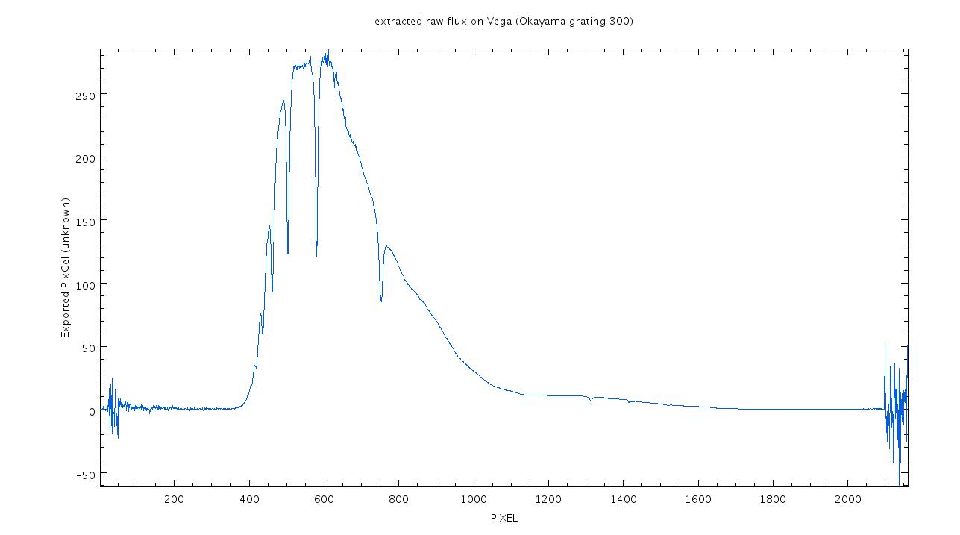
Fig 4: Raw extracted flux of Vega - low dispersion mode
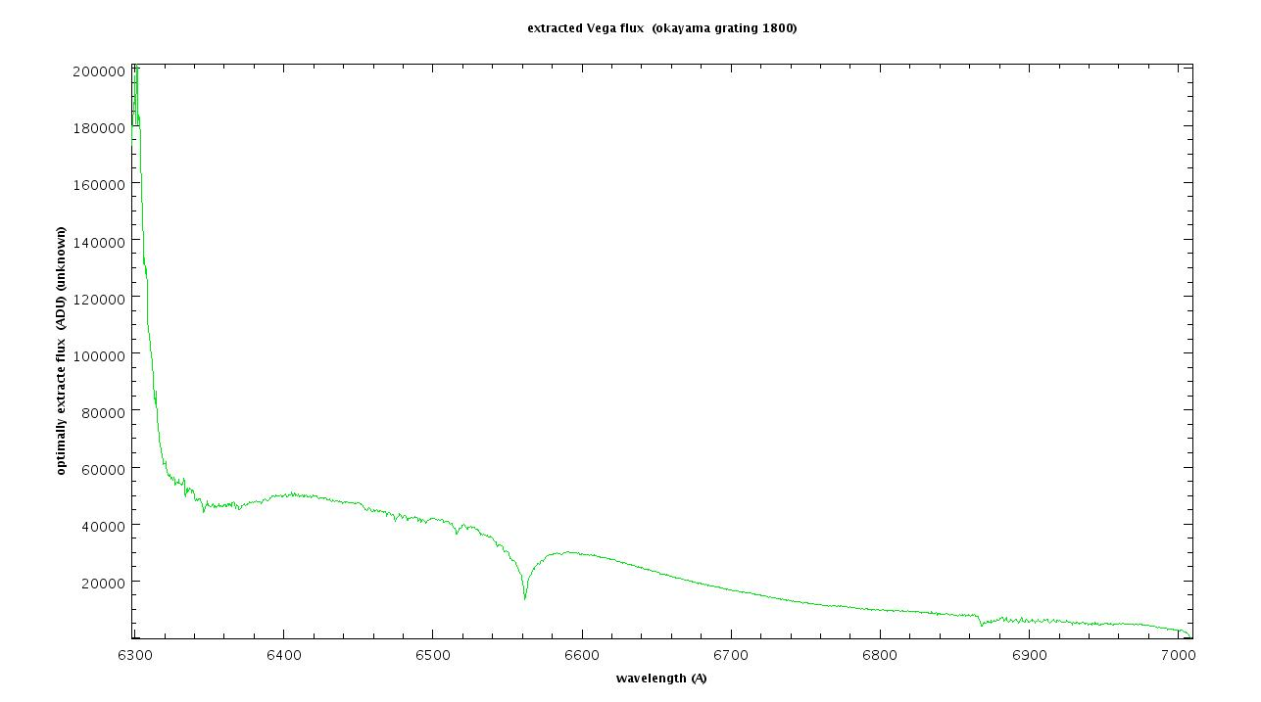
Fig 5: Raw extracted flux of Vega - high dispersion mode

The influence of vignettation and missing flat field flux in blue region is clearly seen. To be able to compare the Kottamia observation with Ondřejov exposures the spectra had to be normalized (which was not easy due to strange shape of spectrum).
The resulting comparison with Ondřejov coude 700mm camera (resolving power about 13000) and high resolution echelle spectrograph OES (resolving power about 70000) is shown on Figs. 6 and 7.

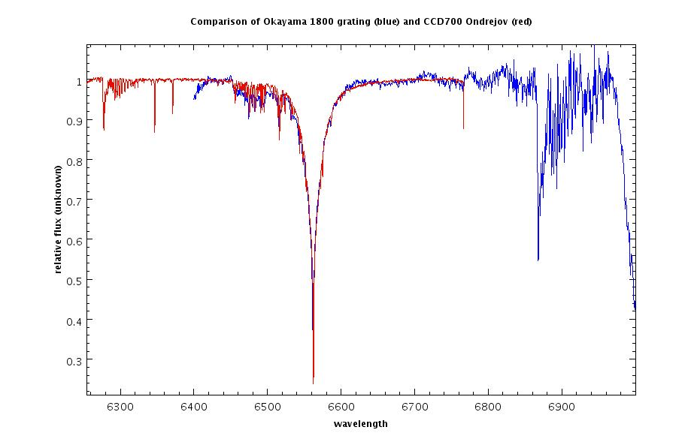
Fig 6: Comparison of high dispersion mode with Ondřejov coude 700mm camera exposure
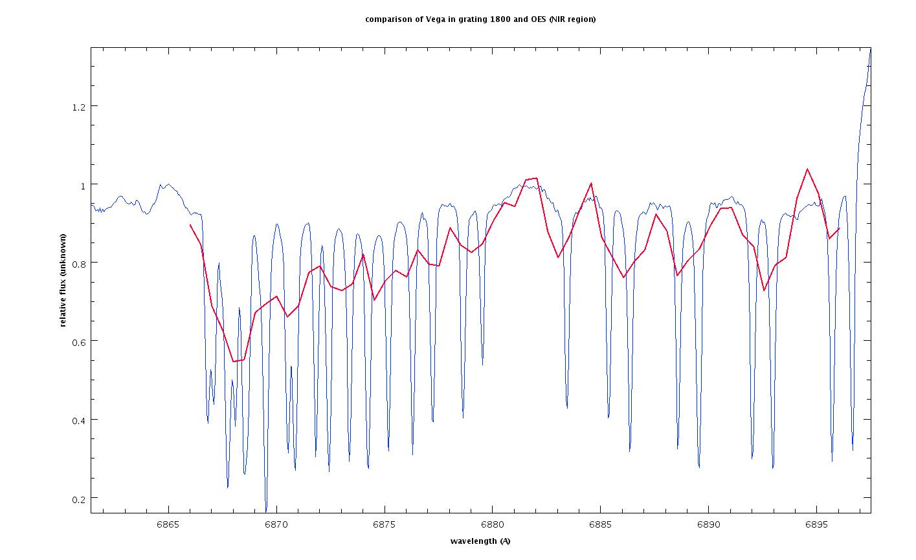
Fig 7: Comparison of high dispersion mode with Ondřejov echelle spectrograph OES in NIR region

The comparison of spectral range covered by the 300 and 1800 gr/mm gratings shows the Fig. 8.

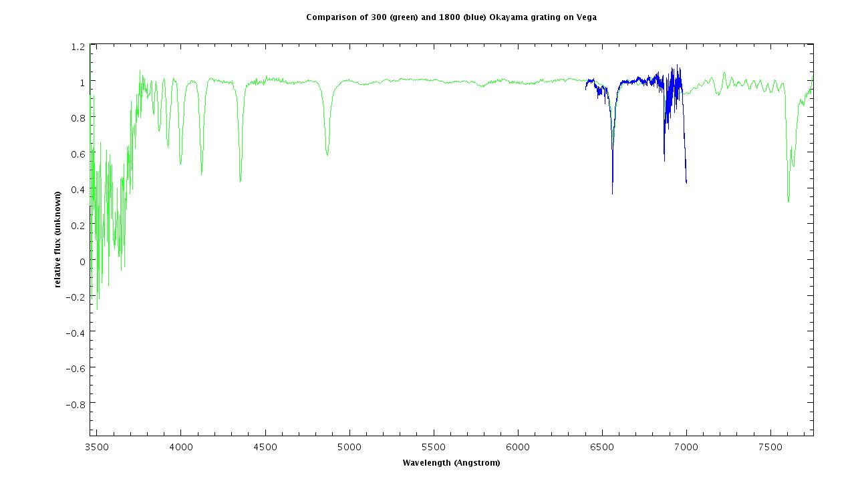
Fig 8: Comparison of Okayama 300/mm and 1800/mm grating spectral range

Archiving and reduction issues
The data acquisition application Pixcel does not write into the FITS headers any important information about the exposure time and length, telescope position, observer, spectrograph setup or anything else. It is quite common to write all of this into the FITS header by the spectrograph or detector control computer. The rule is to write all relevant information into FITS keywords for future checks as well as to allow the semi-automatic data reduction (using some pipeline) or archiving (when the FITS keywords are imported into the SQL database).
Despite the fact that the Okayama spectrograph is not controlled remotely, the relevant information (now written manually in the log file) should be written in header automatically anyway.
One possible way is the additional script on Linux computer, that monitors particular directory, and when new spectrum occurs here it fills the FITS keywords in the header. Part of the information is static (camera, telescope, detector, SW version, lamp names...), part can be obtained automatically from telescope computer (date, time, telescope position, air pressure, temperatures, exposure length) and part has to be filled manually at the beginning of night (observer name, spectrograph configuration – e.g. grating type, slit size) or written after any change, especially the calibrations – callibration type (flat, comp, dark), grating tilt etc. To make the manual input more pleasant and reliable a simple user interface requiring only touching relevant screen buttons (now follows the comp arc, is the lamp in beam ? is it on ? Are you sure ? …) as a „flight check-list“ might be helpful.
In any case having the FITS file headers filled with all necessary information will allow the semi-automatic reduction to be performed in IRAF as well as automatic archiving and database ingestion.

Time synchronisation
The precise time-keeping information written into FITS header is necessary to allow precise reduction (e.g. heliocentric correction of radial velocity) of spectra as well as to allow the chronological ordering and selection of nearest calibrations or checking of observed stellar coordinates. The Kottamia telescope control system is synchronized by GPS server. However at the beginning the synchronization was not applied due to problem in set-up of firewall in the internal TCS network. After recognizing, however, the problem, the corrective actions were performed soon.

Recommendations of observing strategies
The high dispersion mode may be used for study of line profile variations of various Be stars, for measurement of radial velocities of suspected binary stars as well as for abundance analysis work. The low resolution mode covers whole visible spectral range and thus it might be used for spectral classification of observed objects using the absolute flux calibrated spectra. To achieve this a selected flux standards have to be observed at the same time as the main target and the IRAF tasks „setairmass“, „standard“, „sensfunc“ and “calibrate“ used

Spectrum reduction options
We recommend to learn the basic skills in IRAF as well as to follow the IRAF.NET discussion lists. The IRAF should be run on Linux computers, where it performs quite better than on e.g. Windows due to its memory management. However, IRAF is quite complicated and modular. So as an alternative a Windows programs for amateur spectroscopy processing called IRIS may be used.

Conclusions
The Kottamia telescope with Okayama spectrograph provides the good instrumentation for modern stellar research. In low resolution mode even the brighter extragalactic objects like AGNs or quasars may be reachable after sufficiently long exposure time. The excellent quality of CCD with low readout noise as well as deep LN2 cooling to -140 C resulting in negligible dark current should be fully exploited after successful repair of the controller electronics.

Ondřejov, 10th June 2008 Petr Škoda

